CSA1411-COMPILER DESIGN

LAB EXPERIMENTS

NAME:- R KALAI AMUDHAN

REG NO:- 192511292

EXPERIMENT – 3:
AIM:-
Design a lexical Analyzer for a given language should ignore the redundant spaces, tabs, and new lines and ignore comments.
CODE:-
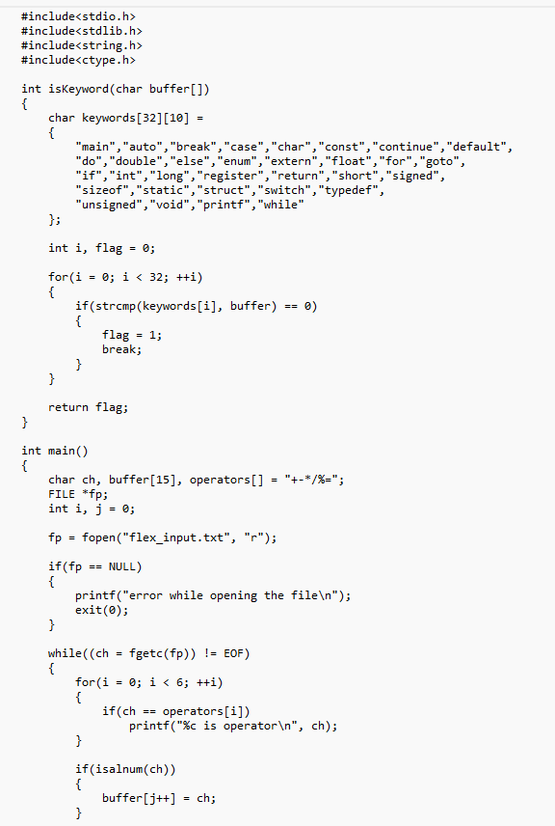

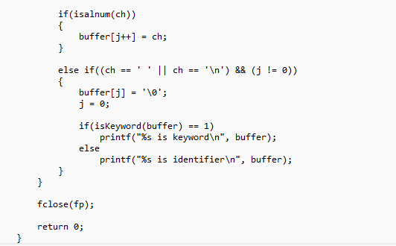

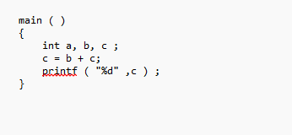
INPUT:-

OUTPUT:-
